VT WOODHILL UK EQUITY STRATEGIC FUND

Managed by Woodhill Asset Management LLP

NEWSLETTER JULY 2022

**Bloomberg ID: VTWARNI LN SEDOL: BMTRT64 ISIN: GB00BMTRT641**

**Fund value at midday 29th July was 78.5447**

**Assets under management: £24.4m**



**VT WoodHill UK Equity Strategy Fund, dividends re-invested (UK p)**

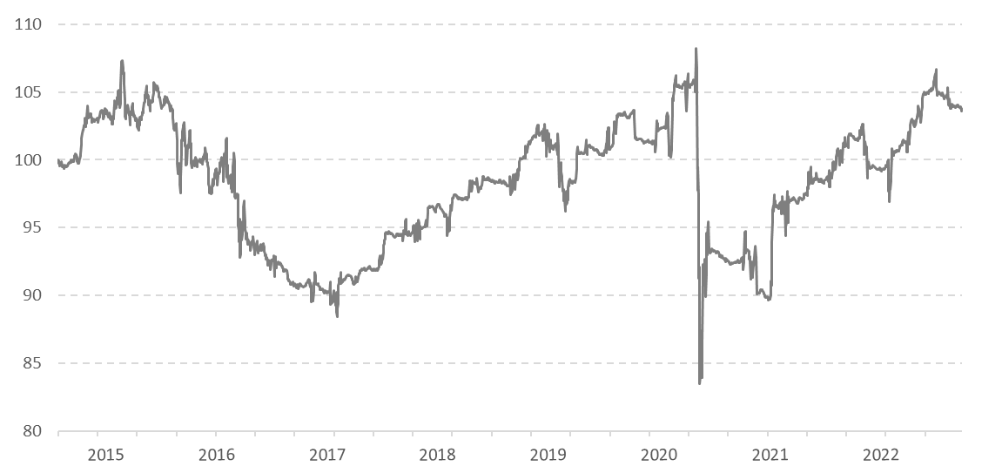

PAST PERFORMANCE IS NOT NECESSARILY INDICATIVE OF FUTURE RESULTS

*Source: VTIM*

July was another slightly disappointing month for us, we were fully hedged1 for the entire period. Overall stock markets did bounce but we have continued to focus on data and news developments rather than try to follow what can, at times, be violent moves in sentiment and momentum. These are very unusual times, and we feel that an especially careful and data driven approach is appropriate.

The bounce that markets have seen this month has been driven, we believe, by extremes in negative sentiment and by low positioning, both of which have now somewhat reversed themselves. We do follow sentiment very closely ourselves and it was absolutely the case that sentiment had been very low. In less tricky times we may have been tempted to think about removing the hedge in response to such low levels of sentiment, but we also recognise that there is a relationship between sentiment and reality which is often an evolving process. We try to exploit the difference between reality (often represented by data) and sentiment (what the market believes).

Something unusual happened in July. Sentiment had become quite negative, but at the same time ‘reality’ represented by both data and news got worse. Over the month, and especially in the second half of July, sentiment has been more positive (or rather less negative) while the actual situation has worsened. For us this is not a great risk reward set up. In any bear market there can be rallies but unless the situation is improving these rallies are often dangerous to chase.

So, why do we think that things have got worse? There are a few things but the main one is that central banks are continuing to increase interest rates into economies that are weakening. Just in the last week the US put up interest rates again and at the same time our favourite high frequency economic data series weakened noticeably. This fast moving, and reliable economic data series now shows a negative economic momentum which is similar in its negativity to that seen in September 2008. This was just about the time of the Lehman crisis when the Western world’s housing market and whole financial system was entering a dangerous looking meltdown.

One striking difference between 2008 and today is that in September 2008 the US Federal Reserve had been cutting interest rates all year. Now, central banks are putting up interest rates and are likely to put them up more before things are done. Overall, it looks as if Western economies are heading for what could be a dramatic slowdown while central banks will be increasing interest rates rather than cutting them. There is lots of other data to suggest that the economic outlook is deteriorating fast. Consumer confidence in Europe and in the US both point towards a very weak economic outlook. For Europe and the US this has been the case for a while, but, in the last month Chinese consumer confidence has also suddenly fallen sharply. Chinese consumers now have less confidence than they did during the Asian crisis.

Quite apart from the data it is also the case that the news flow has, from our perspective, got worse. Italy is now facing a general election, in which, based on current opinion polls, a populist and even Eurosceptic government could come to power in the autumn. On top of this it does seem that Russia wants to use gas supply (especially to Germany) as a political tool to put pressure on Europe to stop backing Ukraine, and, or to ferment a fragmentation of Europe as a whole. Relations between the US and China appear to be fraught again – this time over Taiwan. China still seems to be struggling with its covid policies. We could easily be looking at a very difficult economic and political autumn and winter.

Finally, it is also worth pointing out that recent inflation data in Europe, UK and the US have all come in stronger (i.e., more inflation) than expected. Stock and bond markets have become somewhat enthusiastic about inflation having crested, and that we may soon be on our way to a peak in interest rates, perhaps followed by cuts, and even possibly the end of QT* and the resumption of QE*. Now, not only is there no evidence for this but instead the actual data, so far at least, has been going the other way. Certain pockets of the investment community seem to believe that the economy will weaken enough to cause central banks to reverse direction while such weakness will not really be enough to cause substantial damage to corporate earnings.

While anything is possible, we believe that there is an aspect of wishful thinking to this view. Historically bear markets can be described as having three stages. The first is where excessive enthusiasm comes out of the market, the second is then a sharp decline in corporate earnings and then finally a ‘liquidation’ phase. We may not get to this last stage before central banks act, but we suspect that the next earnings season could be much more difficult than the current one. From our perspective at least one more phase of the current bear market is likely to occur between now and the end of the year. As such we do not want to play around with trying to gauge swings in sentiment and or positioning, against what is a worsening background. We believe that this is dangerous. We will continue to follow the data as closely and dispassionately as we can, and procced with caution until we can see a turn.

As always, we would like to thank everyone involved with our fund.

*\*QT; quantitative tightening, QE; quantitative easing.*

TOP FIFTEEN EQUITY HOLDINGS 29th JULY 2022



Fund manager: Paul Wood

3rd August 2022

[www.woodhillam.co.uk](http://www.woodhillam.co.uk)

Disclaimer

*The information in this Report is presented by Woodhill using all reasonable skill, care and diligence and has been obtained from or is based on third party sources believed to be reliable but is not guaranteed as to its accuracy, completeness or timeliness, nor is it a complete statement or summary of any securities, markets or developments referred to. The information within this Report should not be regarded by recipients as a substitute for the exercise of their own judgement.*

*The information in this Report has no regard to the specific investment objectives, financial situation or particular needs of any specific recipient and is published solely for informational purposes and is not to be construed as a solicitation or an offer to buy or sell any securities or related financial instruments. In the absence of detailed information about you, your circumstances or your investment portfolio, the information does not in any way constitute investment advice. If you have any doubt about any of the information presented, please consult your stockbroker, accountant, bank manager or other independent financial advisor.*

*Value of investments can fall as well as rise and you may not get back the amount you have invested. Income from an investment may fluctuate in money terms. If the investment involves exposure to a currency other than that in which acquisitions of the investments are invited, changes in the rates of exchange may cause the value of the investment to go up or down. Past performance is not necessarily a guide to future performance.*

*Any opinions expressed in this Report are subject to change without notice and Woodhill is not under any obligation to update or keep current the information contained herein. Sources for all tables and graphs herein are WoodHill unless otherwise indicated.*

*The information provided is "as is" without any express or implied warranty of any kind including warranties of merchantability, non‐infringement of intellectual property, or fitness for any purpose.*

*Because some jurisdictions prohibit the exclusion or limitation of liability for consequential or incidental damages, the above limitation may not apply to you. Users are therefore warned not to rely exclusively on the comments or conclusions within the Report but to carry out their own due diligence before making their own decisions.*

*Woodhill Asset Management LLP and its affiliated companies, employees and appointed representatives of Woodhill Asset Management LLP and its affiliated companies, or individuals connected to them, may have or have had interests of long or short positions in, and may at any time make purchases and/or sales as principal or agent in, the relevant securities or related financial instruments discussed in this Report.*

*No part of this report may be reproduced or distributed in any manner without the written permission of WoodHill Asset Management LLP.*

*Authorised and regulated by the Financial Conduct Authority (FCA), registration number 649832.  
This status can be checked with the FCA on 0800 111 6768, or on the FCA website.*

*Registered in England No: OC389733.*

**If you do not wish to receive any further emails from us, please reply "Unsubscribe" in the subject line.**